2.2 Optimization Techniques in AI:

Deterministic Optimization, Linear Programming Optimization, Integer Programming; Stochastic Optimization; Simulated Annealing, Particle Swarm Optimization (PSO), Swarm intelligence-based optimization, Hill Climbing, Simulated Annealing, Comparison of Search vs. Optimization

----------------------
Optimization techniques play a pivotal role in artificial intelligence (AI), helping to solve various types of problems by finding the best solutions from a set of possible options.
Optimization is the process of finding the best solution from all possible choices. We seek to minimize or maximize a specific objective.
Example; minimize the cost function and maximize the efficiency.

Classification of optimization problems
- By the nature of the variables
- Continuous vs. discrete: In continuous optimization, variables can take on any real-valued number. In discrete optimization, variables must come from a discrete set, such as integers, permutations, or graphs.
  - AI Example: A neural network's weights are continuous variables optimized during training. The Traveling Salesman Problem, which seeks the shortest route visiting a set of cities, is a discrete optimization problem.
- Combinatorial optimization: A subfield of discrete optimization that deals with finding the optimal object from a finite set of possibilities. This is common in scheduling, routing, and logistics.
- By the nature of the constraints
- Unconstrained vs. constrained: An unconstrained problem has no restrictions on the values of the variables. A constrained problem requires variables to satisfy a set of equalities or inequalities.
  - Example: Simple linear regression is often unconstrained. Many real-world problems require constrained optimization, such as scheduling to respect available resources.
- By the number of objectives
- Single-objective vs. multi-objective: A single-objective problem aims to optimize only one objective function (e.g., minimize error). A multi-objective problem simultaneously optimizes two or more conflicting objectives, leading to a set of Pareto optimal solutions.
  - Example: A self-driving car might optimize for both safety and speed.
- By the certainty of the data
- Deterministic vs. stochastic: In deterministic optimization, the data for the problem is known precisely. In stochastic optimization, the problem involves uncertainty or randomness and uses probabilistic methods.
  - Example: Training an AI model on a fixed dataset is a deterministic process. Training a model on a stream of continuously incoming, uncertain data is a stochastic process.
- By the nature of the equations
- Linear vs. nonlinear programming: Linear programming involves an objective function and constraints that are all linear equations. If any of the objective or constraint functions are nonlinear, it's a nonlinear programming problem

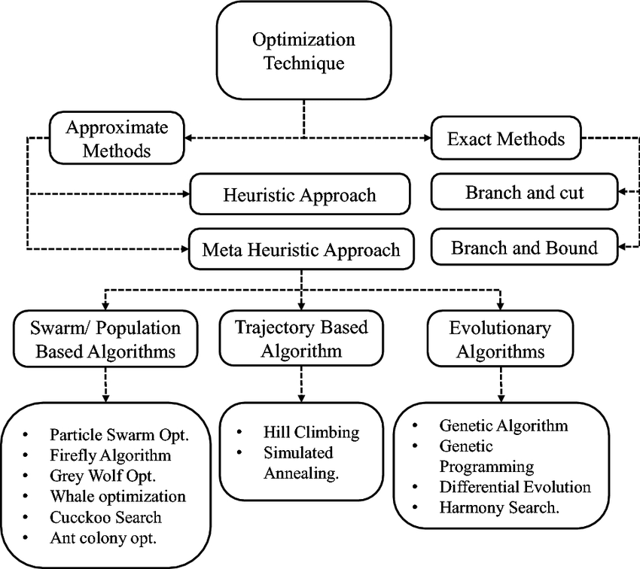

1. Deterministic Optimization

Definition:
Deterministic optimization assumes that the problem’s constraints and objective functions are known with certainty. There is no randomness involved, meaning the solution is predictable given the input data.

Characteristics:
- Objective: Minimize or maximize a defined objective function.
- Approach: Systematically search for an optimal solution using precise methods.
- Outcome: Fixed results for a given input.

Key Methods:
- Gradient Descent: A first-order iterative optimization algorithm to find the minimum of a function. It's widely used in machine learning to minimize the loss function.
- Newton's Method: A second-order optimization method using second derivatives to approximate the minimum or maximum of a function.
- Convex Optimization: Deals with convex objective functions and constraints where local minima are guaranteed to be global minima.

Applications:
- Training deep learning models (e.g., using gradient descent)
- Minimizing error in regression models
- Solving pathfinding problems in robotics

Example 1: Gradient Descent (GD)

Gradient descent is an iterative optimization algorithm that minimizes a function by repeatedly moving in the direction of the steepest descent (the negative of the gradient) until a local minimum is reached. It's widely used in machine learning to train models by finding the optimal parameters (weights and biases) that minimize a cost or loss function, which quantifies the error between the model's predictions and the actual data. The algorithm calculates the gradient, takes a small step in the opposite direction, and repeats this process until the cost function is sufficiently low.

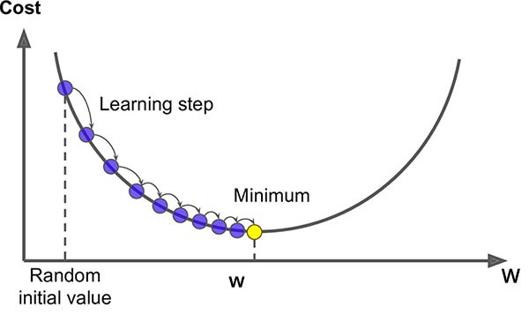

How it works (an analogy):

Imagine you are blindfolded on a hilly landscape and want to find the lowest point (the minimum of the function).

1. Start at a random position:

You begin with an initial guess for your model's parameters.

2. Feel the slope:

You feel the ground around you to determine the steepest downward direction. This direction is given by the gradient, a vector pointing uphill.

3. Take a step downhill:

You take a small step in the opposite direction of the gradient, moving in the direction that decreases the altitude the most.

4. Repeat:

You continue to feel the slope and take steps until you reach the bottom of a valley, which represents the minimum of the function.

Key Steps in Gradient Descent:

1. Initialization:

Start with initial, often random, values for the model's parameters.

2. Cost Function Calculation:

Calculate the cost (or loss) for the current parameters, which measures the error between the model's predictions and the actual data.

3. Gradient Calculation:

Compute the gradient (the first derivative) of the cost function with respect to each parameter. This tells you the direction of the steepest increase in the cost function.

4. Parameter Update:

Adjust the parameters by taking a small step in the direction opposite to the gradient. The size of this step is controlled by a learning rate, a hyperparameter.

5. Iteration:

Repeat steps 2-4 until the model's loss can no longer be reduced or a predetermined number of iterations is reached.

Why is it used?
- Minimizing Errors:

It finds the optimal parameters for a model by minimizing the cost function, thereby reducing the model's errors.
- Learning in AI:

It's the fundamental algorithm for training machine learning and deep learning models, including neural networks, to learn from data.
- Complex Functions:

It's essential for finding the minimum of complex, high-dimensional functions where finding the minimum analytically is difficult or impossible.

Problem:
We have a machine learning model (e.g., linear regression), and we want to minimize the loss function (e.g., Mean Squared Error).

Function:
Let’s say our objective function is the Mean Squared Error (MSE) of a linear regression model:
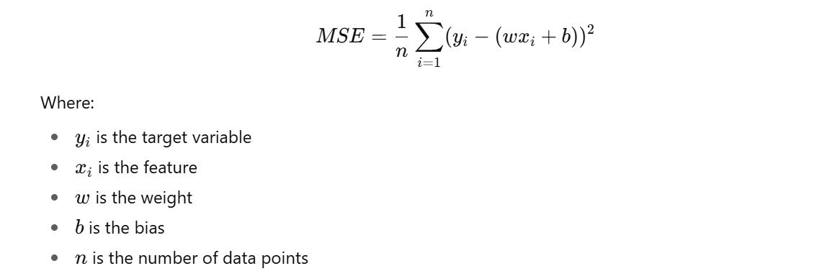

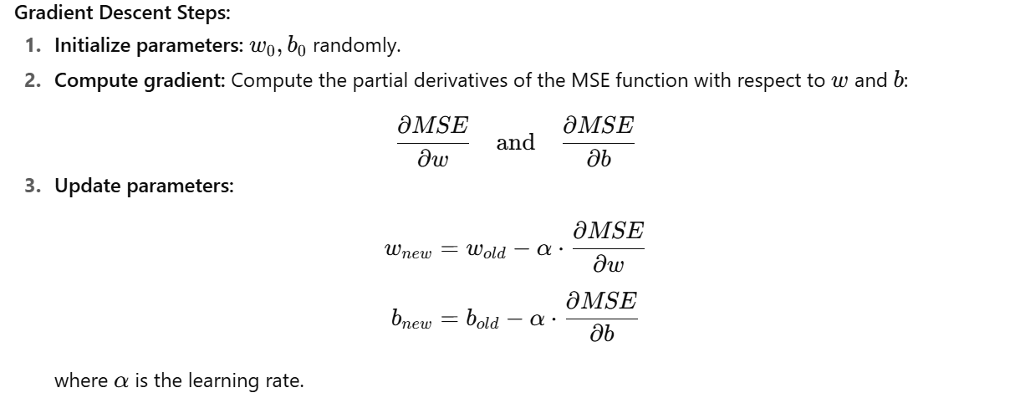

The significance of the learning rate in Machine Learning (ML) is that it controls the step size during the model's optimization process, determining how quickly and effectively the model learns from data.

A low learning rate leads to slow convergence and can cause the model to get stuck in a local minimum, while a high learning rate risks overshooting the optimal solution, causing instability and slow, or failed, convergence. An appropriately set learning rate is crucial for achieving high model performance by balancing the speed of convergence with the accuracy of the solution.

Repeat: Continue until convergence.

Use Case:
Training a linear regression model to predict house prices based on features like size, number of rooms, etc.

2. Linear Programming (LP) Optimization

Definition:
Linear programming is a mathematical technique used for optimization where the objective function and the constraints are linear. LP deals with problems that can be expressed as linear equations.
Linear programming (LP) is a method used in mathematics and optimization to achieve the best outcome (like maximum profit or lowest cost) in a mathematical model whose requirements are represented by linear relationships.
Key Elements of Linear Programming:
- Objective function: The function you want to maximize or minimize (e.g., maximize profit, minimize cost).
- Decision variables: The variables that decide the outcome (e.g., how many units of product A and B to produce).
- Constraints: Linear inequalities or equations that restrict the values of decision variables (e.g., resource limits).
- Non-negativity restrictions: Decision variables are usually required to be zero or positive.
Standard Mathematical Formulations
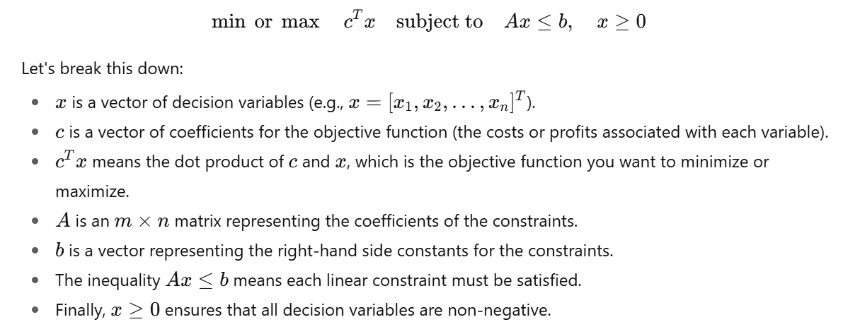

Methods:
- Simplex Algorithm: A popular method for solving LP problems, though it’s not polynomial-time in the worst case.
- Interior Point Methods: More efficient for large problems, used in modern solvers like CPLEX and Gurobi.

Applications:
- Resource allocation (e.g., supply chain optimization)
- Financial portfolio optimization
- Diet planning and other practical decision-making problems

Strengths:
- Solvable in polynomial time for large problems with efficient solvers.
- Handles multiple variables and constraints simultaneously.

: Resource Allocation Problem

Problem:
You run a factory and need to allocate resources (e.g., machines, workers) to maximize profit. The problem is subject to constraints such as limited resources (machines, time) and specific requirements (how much time each worker spends on each machine).

Formulation:
Maximize profit PPP:
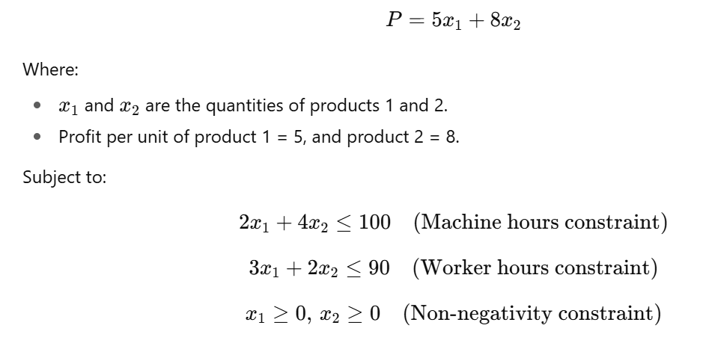
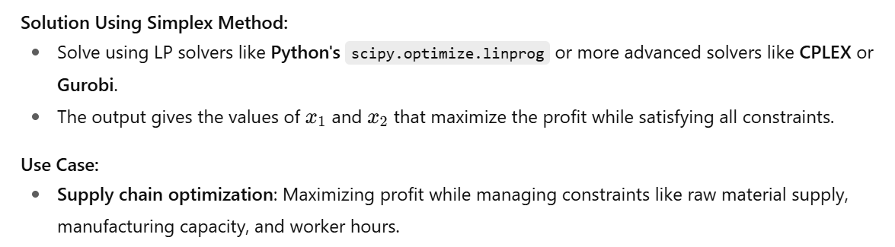

Example 2.
A factory produces two products, Product A and Product B.
- Profit per unit of Product A = $40
- Profit per unit of Product B = $30
The factory has two constraints:
- Labor hours:
Product A requires 2 hours per unit
Product B requires 1 hour per unit
Maximum available labor hours = 100 hours
- Material units:
Product A requires 3 units of material per unit
Product B requires 2 units of material per unit
Maximum available material = 120 units

Goal:
Maximize total profit by deciding how many units of Product A and Product B to produce.

Step 1: Define variables
- xxx = number of units of Product A produced
- yyy = number of units of Product B produced

Step 2: Write the objective function

Maximize Z=40x+30y

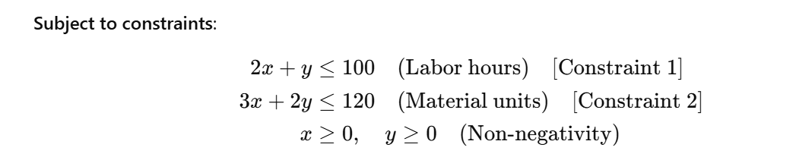

Step 1: Plot the Constraints

3. Integer Programming (IP)

Definition:
A subset of linear programming where some or all of the variables are restricted to integer values. This is useful when the decision variables represent discrete choices (e.g., selecting a facility, number of workers).

Types:
- Pure Integer Programming: All decision variables must be integers.
- Mixed Integer Programming (MIP): Some variables are continuous, while others are restricted to integer values.

Methods:
- Branch and Bound: A tree-based search method to explore feasible solutions, often used for solving integer programming problems.
- Cutting Plane Method: Iteratively refines the feasible region of the problem to converge toward the optimal solution.

Applications:
- Scheduling (e.g., employee shift scheduling)
- Network design and facility location problems
- Combinatorial optimization problems like the Traveling Salesman Problem (TSP)

Challenges:
- NP-hard, meaning the solution time grows exponentially with problem size.
- Solvers often need to balance performance and computational resources (e.g., Gurobi, IBM CPLEX).

Solution Using Branch and Bound:
- You can use the Branch and Bound method or solvers like Gurobi to find the optimal solution (which job goes to which machine to minimize makespan).
Use Case:
- Manufacturing systems: Scheduling jobs on limited machines.
- Transportation: Assigning delivery trucks to routes.

4. Stochastic Optimization

Definition:
Stochastic optimization techniques involve randomness in the optimization process. These methods are particularly useful when the objective function or constraints have uncertainty or noise (e.g., in real-world data).

Key Methods:
- Stochastic Gradient Descent (SGD): A variation of gradient descent where only a subset of the data (a mini-batch) is used to compute each gradient, making it more scalable for large datasets.
- Evolutionary Algorithms: These include genetic algorithms that simulate natural selection, mutation, and crossover to find near-optimal solutions.
- Simulated Annealing: A probabilistic technique inspired by physical annealing, where the algorithm allows occasional worse solutions to escape local optima.
- Bayesian Optimization: Used for optimizing expensive or noisy functions, often used for hyperparameter tuning.

Applications:
- Reinforcement learning (where state transitions are not deterministic)
- Hyperparameter optimization in machine learning
- Complex decision-making processes under uncertainty

Pros:
- Good for noisy or incomplete data
- Can avoid getting trapped in local optima

Cons:
- Results may vary due to randomness
- Computationally expensive in certain scenarios

Stochastic Gradient Descent (SGD)

Problem:
Training a neural network with large datasets where calculating the gradient over the entire dataset is computationally expensive.

Method:
Stochastic Gradient Descent (SGD) uses a subset (mini-batch) of data to compute the gradient and update weights, making it computationally more feasible.
- Initialize weights randomly.
- Select a mini-batch of data points.
- Compute gradient using just that mini-batch.
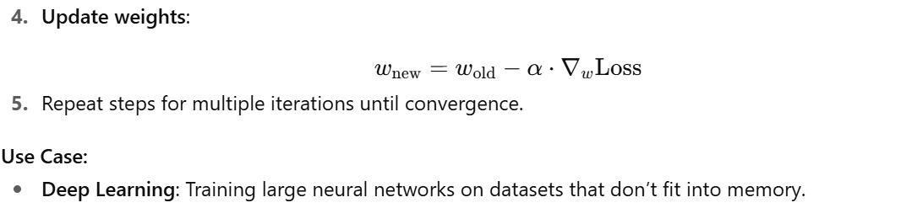

5. Simulated Annealing

Definition:
Simulated Annealing (SA) is a probabilistic optimization technique inspired by the physical process of heating a material and then slowly cooling it to remove defects. The idea is to explore the solution space by occasionally accepting worse solutions to escape local minima.

How it Works:
- Start with an initial solution.
- Generate a neighboring solution.
- If the new solution is better, accept it.
- If the new solution is worse, accept it with some probability (depends on temperature).
- Gradually decrease the "temperature" over time.

Applications:
- Combinatorial problems like TSP (Traveling Salesman Problem)
- Feature selection in machine learning models
- Structural optimization in engineering

Strengths:
- Can escape local optima
- Simple and versatile

Challenges:
- Requires careful tuning of the cooling schedule
- Computationally expensive for large-scale problems

Traveling Salesman Problem (TSP)

Problem:
Given a set of cities, find the shortest possible route that visits each city exactly once and returns to the starting city.

Solution with Simulated Annealing:
- Initial Solution: Start with a random route.
- Neighbor Solution: Swap two cities’ positions to create a new route.
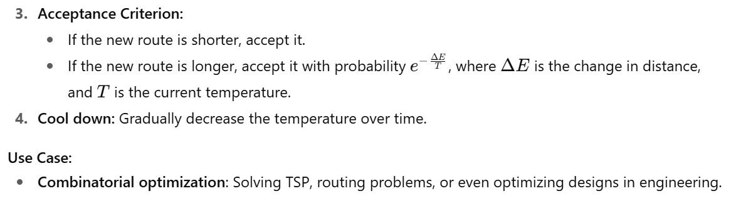

6. Evolutionary Algorithms

Definition:
Evolutionary algorithms are a family of optimization techniques that mimic the process of natural evolution. They work by iteratively improving a population of candidate solutions through processes inspired by natural selection, crossover, and mutation.

Key Methods:
- Genetic Algorithms (GA): Use crossover and mutation to evolve solutions.
- Genetic Programming (GP): A specific type of GA that evolves computer programs to solve problems.

Applications:
- Feature engineering and selection in machine learning
- Multi-objective optimization
- Evolutionary robotics

Strengths:
- Suitable for complex, multimodal optimization problems
- Can handle large search spaces and non-differentiable functions

Example 6: Genetic Algorithm (GA) for Feature Selection

Problem:
We want to select the best subset of features from a large set of features to improve a machine learning model’s performance.

Steps:
- Initialize population: Randomly select subsets of features.
- Fitness function: Evaluate subsets using the model’s performance (e.g., accuracy, AUC).
- Selection: Select the best-performing subsets.
- Crossover: Combine features from selected subsets to create new ones.
- Mutation: Randomly change some features in the subsets.
- Repeat until convergence or a set number of generations.

Comparison of Optimization Methods
Technique | Determinism | Handles Uncertainty | Type of Variables | Use Cases
Deterministic Optimization | Yes | No | Continuous | Machine learning training, pathfinding
Linear Programming | Yes | No | Continuous | Resource allocation, transportation
Integer Programming | Yes | No | Integer | Scheduling, routing, facility planning
Stochastic Optimization | No | Yes | Any | Reinforcement learning, hyperparameter tuning
Simulated Annealing | No | Yes (probabilistic) | Any | TSP, combinatorial problems
Evolutionary Algorithms | No | Yes | Any | Feature selection, evolutionary robotics

Hill Climbing Algorithm in Artificial Intelligence
6 May 2025 | 10 min read
Hill climbing algorithm is a local search algorithm that continuously moves in the direction of increasing elevation/value
to find the peak of the mountain or the best solution to the problem. It terminates when it reaches a peak value where no
neighbor has a higher value.
It is a technique which is used for optimizing the mathematical problems. One of the widely discussed examples of
Hill climbing algorithm is Traveling-salesman Problem in which we need to minimize the distance traveled by
the salesman.
It is also called greedy local search as it only looks to its good immediate neighbor state and not beyond that.
A node of hill climbing algorithm has two components which are state and value. Hill Climbing is mostly used
when a good heuristic is available. In this algorithm, we don't need to maintain and handle the search tree or graph,
as it only keeps a single current state.
Advantages of Hill climb algorithm:
The merits of the Hill Climbing algorithm are given below.
- The first part of the paper is based on Hill's diagrams that can easily put things together, ideal for complex
optimization problem. A hill climbing algorithm is first invention of hill climbers.
- It uses much less RAM for the current problem state and the solutions located around it than comparing the
algorithm to a tree search method, which will require inspecting the entire tree. Consequently, this reduces the total
memory resources to be used. Space is what matters; solutions should occupy a convenient area to consume as little memory as possible.
- When it comes to the acceleration of the hill up, most of the time it brings a closure in the local maximum straight
away. This is the route if having quickly getting a quick solution, outshining acquiring a global maximum, is an
incentive.
Disadvantages of Hill Climbing Algorithm
- Concerning hill climbing, it seems that some solutions do not find the optimum point and remain stuck at a
local peak, particularly where the optimization needs to be done in complex environments with many objective functions.
- It is also superficial because it just seeks for the surrounding solution and does not get farther than that.
It could be on a wrong course which is based on a locally optimal solution, and consequently Godbole needs to
move far away from current position in the first place.
- It is highly likely that the end result will largely depend on the initial setup and state, with a precedent of it
being the most sensitive factor. It implies that in this case, time is the perimeter of the sphere within which people
develop their skills dynamically, determining their success.
Features of Hill Climbing:
The following are some main features of the Hill Climbing Algorithm:
- Generate and Test variant: Hill Climbing is a variant of the Generate and Test method. The Generate and Test
method produces feedback that helps to decide which direction to move in the search space.
- Greedy approach: Hill-climbing algorithm search moves in the direction that optimizes the cost.
- No backtracking: It does not backtrack the search space, as it does not remember the previous states.
- Deterministic Nature: Hill Climbing is a deterministic optimization algorithm, which means that given the same
initial conditions and the same problem, it will always produce the same result. There is no randomness or uncertainty in its operation.
- Local Neighborhood: Hill Climbing is a technique that operates within a small area around the current solution.
It explores solutions that are closely related to the current state by making small, gradual changes. This approach
allows it to find a solution that is better than the current one, although it may not be the global optimum.
State-space Diagram for Hill Climbing:
The state-space landscape is a graphical representation of the hill-climbing algorithm which is showing a graph between
various states of algorithm and Objective function/Cost.
On Y-axis we have taken the function which can be an objective function or cost function, and state-space on the x-axis.
If the function on Y-axis is cost then, the goal of search is to find the global minimum and local minimum. If the function
of Y-axis is Objective function, then the goal of the search is to find the global maximum and local maximum.
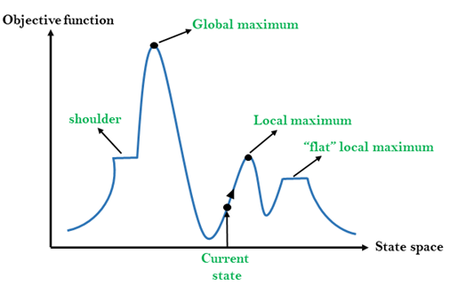
Different regions in the state space landscape:
- Local Maximum: Local maximum is a state which is better than its neighbor states, but there is also another state
which is higher than it.
- Global Maximum: Global maximum is the best possible state of state space landscape. It has the highest value of
objective function.
- Current State: It is a state in a landscape diagram where an agent is currently present.
- Flat local maximum: It is a flat space in the landscape where all the neighboring states of the current state have
the same value.
- Shoulder: It is a plateau region that has an uphill edge.
Types of Hill Climbing Algorithm:
- Simple hill Climbing:
- Steepest-Ascent hill-climbing:
- Stochastic hill Climbing:
1. Simple Hill Climbing:
Simple hill climbing is the simplest way to implement a hill-climbing algorithm. It only evaluates the neighbor node state
at a time and selects the first one that optimizes the current cost, and sets it as the current state. It only checks its one
successor state, and if it finds a better state than the current state, then it moves, else it remains in the same state. This
algorithm has the following features:
- Less time-consuming
- A less optimal solution, and the solution is not guaranteed
Algorithm for Simple Hill Climbing:
- Step 1: Evaluate the initial state. If it is the goal state, then return success and Stop.
- Step 2: Loop until a solution is found or there is no new operator left to apply.
- Step 3: Select and apply an operator to the current state.
- Step 4: Check the new state:
  - If it is the goal state, then return success and quit.
  - Else if it is better than the current state, then assign the new state as the current state.
  - Else if not better than the current state, then return to step 2.
- Step 5:
2. Steepest-Ascent hill climbing:
The steepest ascent algorithm is a variation of the simple hill climbing algorithm. This algorithm examines all the
neighboring nodes of the current state and selects one neighbor node that is closest to the goal state. This algorithm
consumes more time as it searches for multiple neighbors.
Algorithm for Steepest-Ascent hill climbing:
- Step 1: Evaluate the initial state. If it is the goal state, then return success and stop; else make the current state
as initial state.
- Step 2: Loop until a solution is found or the current state does not change.
  - Let SUCC be a state such that any successor of the current state will be better than it.
  - For each operator that applies to the current state:
    - Apply the new operator and generate a new state.
    - Evaluate the new state.
    - If it is the goal state, then return it and quit; else, compare it to the SUCC.
    - If it is better than SUCC, then set the new state as SUCC.
    - If the SUCC is better than the current state, then set the current state to SUCC.
- Step 5:
3. Stochastic hill climbing:
Stochastic hill climbing does not examine for all its neighbor before moving. Rather, this search algorithm selects one
neighbor node at random and decides whether to choose it as a current state or examine another state.
Hybrid Methods
Although Hill Climbing Algorithm is a very efficient and useful local search technique, there are several drawbacks
including plateaus, ridges, and local maxima trapping. To surpass these limitations and produce better optimization solutions, experts and practitioners usually employ hybrid approaches combining hill climbing with other algorithms addressing its
shortcomings.
1. Hill climbing combined with simulated annealing
Controlled randomness is introduced into the search process using a technique called simulated annealing. Simulated
annealing rejects states with poorer fitness according to a random probability function; hill climbing only rejects ones that
improve fitness (in this case, a higher value). Simulated annealing can push through a local peak if hill climbing reaches
one by accepting a small value drop, and allow the search to explore other areas of the solution space.
2. Mountain Climbing and Genetic Algorithms
Mutation, crossover, and selection are three types of techniques used by genetic algorithms (GAs). Hill climbing is one
local optimizer in genetic algorithms. After a new one is created with crossover and mutation, hill climbing can be
employed to iterate or &quot; polish" that solution for enhancement. Together, GAs provide great better quality solution
and faster convergence time; hill climbing local search together can.
3. Memetic Algorithms' Hill Climbing
Sophisticated hybrids of evolutionary algorithms, memetic algorithms combine other kinds of individual learning or local
search with local refining methods like hill climbing. Before it enters the next generation, every candidate solution in
Memetic Algorithms is subject to local improvement by hill climbing. Since this method is balanced, the search process is
more intelligent: the GA permits exploration (by random search for mutations and crossover) and the hill climbing provides the exploitation (by local search).
Problems in Hill Climbing Algorithm:
  - Local Maximum: A local maximum is a peak state in the landscape which is better than each of its
neighboring states, but there is another state also present which is higher than the local maximum.
Solution: Backtracking technique can be a solution of the local maximum in state space landscape. Create a list of the
promising path so that the algorithm can backtrack the search space and explore other paths as well.
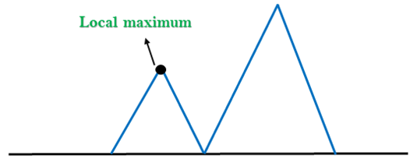
  - Plateau: A plateau is the flat area of the search space in which all the neighbor states of the current state contain the
same value, because of this algorithm does not find any best direction to move. A hill-climbing search might be lost in the plateau area.
Solution: The solution for the plateau is to take big steps or very little steps while searching, to solve the problem.
Randomly select a state which is far away from the current state so it is possible that the algorithm could find non-plateau region.
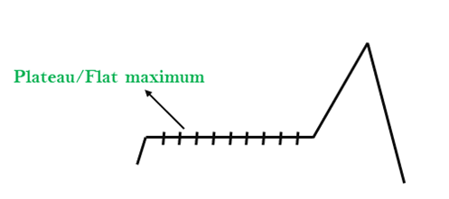
  - Ridges: A ridge is a special form of the local maximum. It has an area which is higher than its surrounding areas, but it
has a slope, and cannot be reached in a single move.
Solution: With the use of bidirectional search, or by moving in different directions, we can improve this problem.
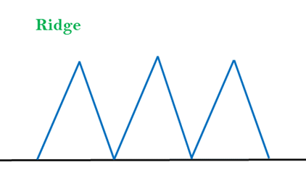
Simulated Annealing:
A hill-climbing algorithm that never makes a move towards a lower value is guaranteed to be incomplete because it can
get stuck on a local maximum. And if algorithm applies a random walk, by moving a successor, then it may complete but
not efficient. Simulated Annealing is an algorithm which yields both efficiency and completeness.
In mechanical terms, Annealing is a process of hardening a metal or glass to a high temperature, then cooling gradually, so
this allows the metal to reach a low-energy crystalline state. The same process is used in simulated annealing, in which the
algorithm picks a random move, instead of picking the best move. If the random move improves the state, then it follows
the same path. Otherwise, the algorithm follows the path that has a probability of less than 1, or it moves downhill and
chooses another path.
Applications of Hill Climbing Algorithm
The hill-climbing technique has seen widespread usage in artificial intelligence and optimization, respectively. It
methodically solves those problems via coupled research activities by systematically testing options and picking out the
most appropriate one. Some of the applications are as follows:
Some of the application are as follows:
1. Machine Learning:
Fine tuning of machine learning models frequently is doing the hyper parameter optimization that provides the model with
guidance on how it learns and behaves. Another exercise which serves the same purpose is hill training. Gradual
adjustment of hyperparameters and their evaluation according to the respectively reached the essence of the hill climbing
method.
2. Robotics:
In robotics, hill climbing technique turns out to be useful for an artificial agent roaming through a physical environment
where its path is adjusted before arriving at the destination.
3. Network Design:
The tool may be employed for improvement of network forms, processes, and topologies in the telecommunications
industry and computer networks. This approach erases the redundancy thus the efficiency of the networks are increased by
studying and adjusting their configurations. It facilitates better cooperation, efficiency, and the reliability of diverse
communication system.
4. Game playing:
Altough the hill climbing can be optimal in game playing AI by developing the strategies which helps to get the maximum
scores.
5. Natural language processing:
The software assists in adjusting the algorithms to enable the software to be efficient at dealing with the tasks at hand such
as summarizing text, translating languages and recognizing speech. These abilities owing to it as a significant tool for many applications.
Implementation
Now we will try to maximize the function with the help of the Hill Climbing algorithm: f (x) = -x² + 5
Code:
- # Importing the libraries
- import random
- import matplotlib.pyplot as plt

- # Defining the function to maximize
- def function_target(val):
- return -val**2 + 5 # A parabola with maximum at x = 0

- # Visualizing the hill-climbing algorithm
- def hill_climbing_with_plot(
- steps_max=1000, step_range=0.1, x_min=-10, x_max=10
- ):
- # Starting with some random solution
- point_current = random.uniform(x_min, x_max)
- value_current = function_target(point_current)

- # Tracking the progress for the purpose of visualization
- history_x = [point_current]
- history_y = [value_current]

- for step in range(steps_max):
- # Generating a neighboring point by adding a small random step
- point_neighbor = point_current + random.uniform(-step_range, step_range)

- # Ensuring that the neighbor stays within limits
- point_neighbor = max(min(point_neighbor, x_max), x_min)
- value_neighbor = function_target(point_neighbor)

- # If the neighbor is better, move to it
- if value_neighbor > value_current:
- point_current = point_neighbor
- value_current = value_neighbor

- # Recording the current best point
- history_x.append(point_current)
- history_y.append(value_current)

- return point_current, value_current, history_x, history_y

- # Running the algorithm
- opt_x, opt_y, path_x, path_y = hill_climbing_with_plot()

- # Getting the final result
- print(f"Optimal x: {opt_x:.4f}, f(x): {opt_y:.4f}")

- # Plotting the function and the hill climbing path
- x_vals = [x / 100.0 for x in range(-1000, 1000)]
- y_vals = [function_target(x) for x in x_vals]

- plt.figure(figsize=(10, 6))
- plt.plot(x_vals, y_vals, label="Target Function: f(x) = -x² + 5", color='blue')
- plt.plot(path_x, path_y, marker='o', color='red', label='Search Path')
- plt.title("Hill Climbing Optimization Path")
- plt.xlabel("x")
- plt.ylabel("f(x)")
- plt.legend()
- plt.grid(True)
- plt.show()
- <textarea>
Output:
Optimal x: -0.0001, f(x): 5.0000
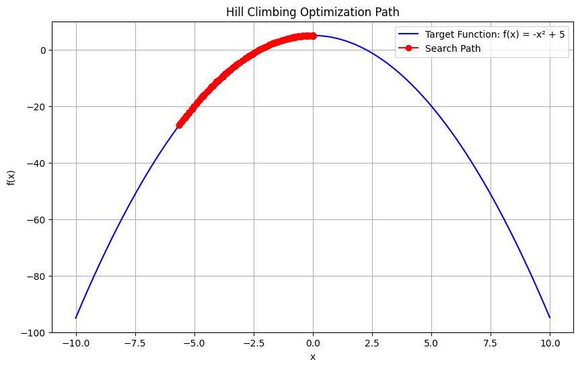
This shows the algorithm has found a value of x close to 0, where the function achieves its maximum.

Particle Swarm Optimization (PSO) –
Particle Swarm Optimization (PSO) is a nature-inspired optimization algorithm that was developed by Dr. James Kennedy and Dr. Russell Eberhart in 1995. The algorithm is based on the social behavior of birds flocking or fish schooling, where individuals (particles) adjust their positions based on their own experience and the experience of neighboring particles.

1. Overview of PSO
PSO is a population-based, stochastic optimization technique, where multiple candidate solutions (called particles) explore the solution space collectively. Each particle adjusts its position based on:
- Its own best-known position (personal best, pbest).
- The best-known position found by any particle in the swarm (global best, gbest).
PSO works by moving particles through the solution space and evaluating their fitness using an objective function. Over time, the particles "swarm" towards an optimal solution.

2. PSO Algorithm: Basic Concepts

Particles:
Each particle represents a potential solution in the search space. Particles have:
- Position: The location in the search space, representing a candidate solution.
- Velocity: The speed and direction of the particle's movement.
- Fitness: The value of the objective function at the particle's current position.

Personal Best (pbest):
Each particle keeps track of the best position it has ever visited (its personal best).

Global Best (gbest):
The best position found by any particle in the entire swarm.

Inertia:
To avoid the particles from overshooting the optimal solution, inertia is introduced. It prevents drastic changes in the velocity and helps particles to explore the search space effectively.

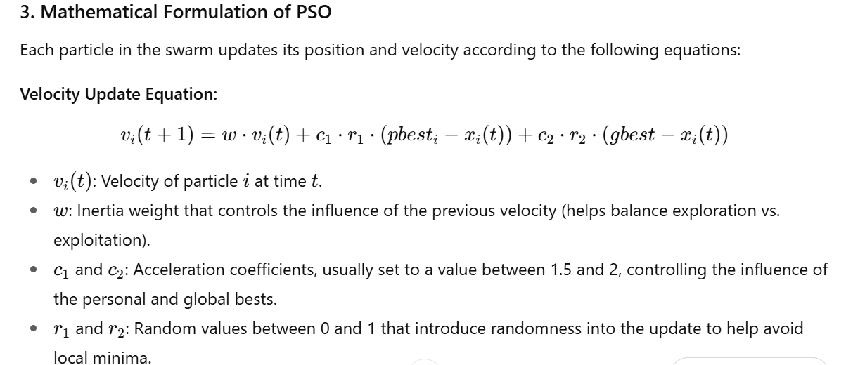
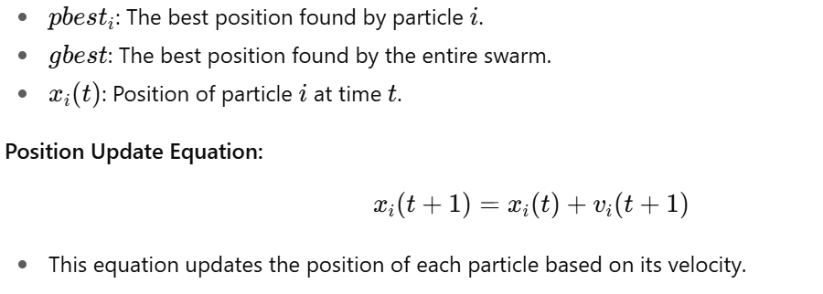

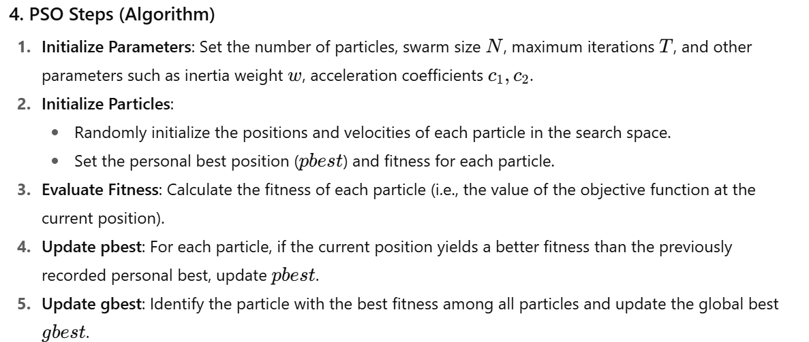
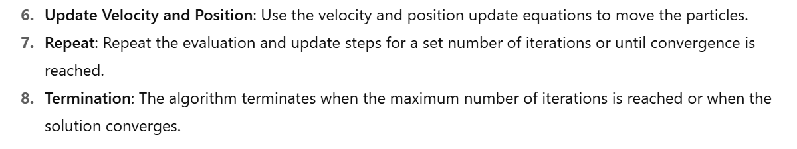

5. PSO Hyperparameters
- Inertia Weight www:
  - Controls the balance between exploration (global search) and exploitation (local search).
  - High www encourages exploration, low www encourages exploitation.
  - Often, www decreases over time to shift from exploration to exploitation.
- Acceleration Coefficients c1,c2c_1, c_2c1​,c2​:
  - These coefficients control how much the personal best and global best influence the particle's movement.
  - Typically set to values between 1.5 and 2.
- Swarm Size:
  - The number of particles in the swarm. A larger swarm increases the likelihood of finding the global optimum but at the cost of higher computational expense.
- Max Iterations (Generations):
  - The number of iterations (or generations) the algorithm will run. The algorithm terminates when this is reached.

6. Advantages of PSO
- Simplicity:
  - PSO is easy to implement and has a minimal set of parameters to tune.
- Flexible:
  - It can be applied to continuous and discrete optimization problems.
  - PSO works well in high-dimensional spaces and is suitable for a variety of optimization tasks.
- Global Search:
  - PSO has a strong ability to avoid local minima due to the swarm's exploration of the search space.
- Parallelism:
  - Since each particle operates independently, PSO can be easily parallelized for distributed computation, making it scalable for large optimization problems.

7. Disadvantages of PSO
- Premature Convergence:
  - PSO may converge too early to a suboptimal solution, especially if the particles get stuck in local optima.
- Sensitive to Parameter Settings:
  - The performance of PSO depends on the settings of the inertia weight www and the acceleration coefficients c1,c2c_1, c_2c1​,c2​. Choosing good values can require trial and error.
- No Guarantee of Global Optimality:
  - As a heuristic method, PSO cannot guarantee finding the global optimum, particularly in very complex, highly multimodal objective functions.

8. Applications of PSO
- Engineering Design:
  - PSO is used in optimizing parameters in various engineering fields such as structural design, circuit design, and aerodynamics.
- Machine Learning:
  - Hyperparameter optimization (e.g., tuning neural network weights and parameters).
  - Feature selection for improving model performance.
- Robotics:
  - Path planning and optimization for autonomous vehicles and robots.
- Signal Processing:
  - PSO is used for optimizing filters and signal estimators.
- Economics and Finance:
  - Portfolio optimization, asset management, and risk assessment.

9. Example of PSO in Python
- Let’s implement a basic example where PSO is used to minimize a simple function
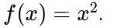

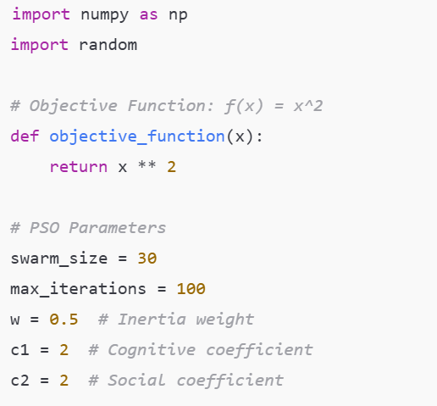
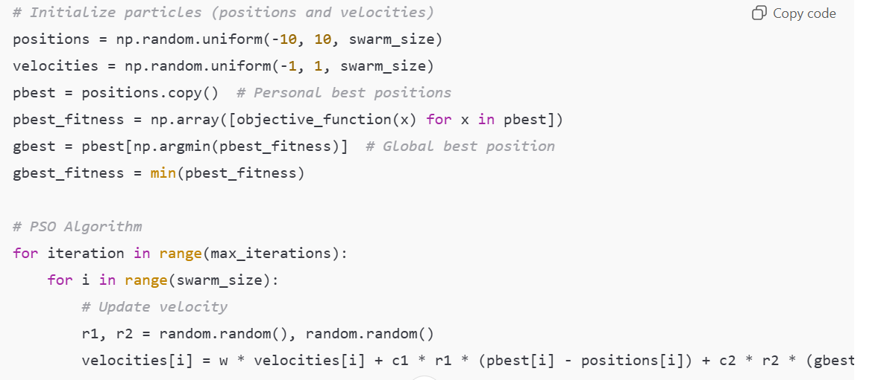
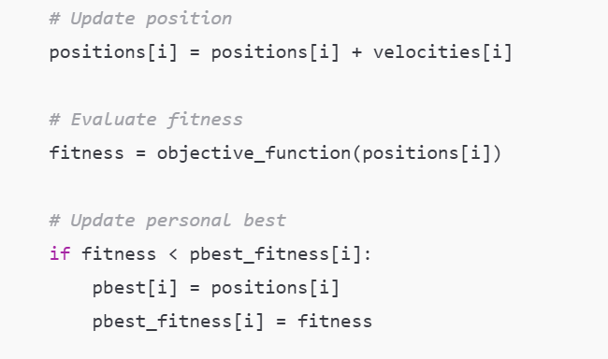
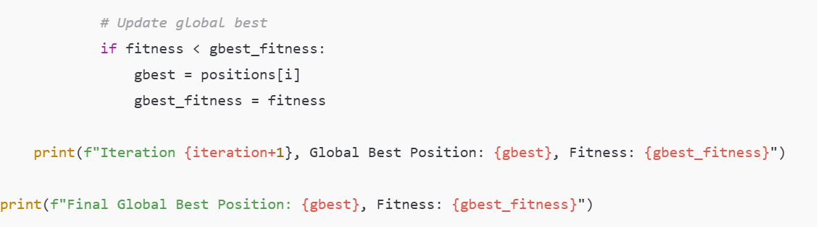
Explanation:
- In this example, particles move to minimize the function
- We initialize a swarm of particles, each with random positions and velocities.
- The particles update their velocities and positions using the PSO update equations, and track the best solutions found.

10. Conclusion
Particle Swarm Optimization is a powerful and versatile optimization technique inspired by nature. It is widely used in engineering, machine learning, and many other fields, thanks to its simplicity and flexibility. However, like all optimization techniques, it has its limitations, including the potential for premature convergence and sensitivity to parameter settings. Properly tuning the hyperparameters and balancing exploration and exploitation are key to achieving optimal performance with PSO.

Swarm Intelligence-Based Optimization: Detailed Technical Notes
Swarm Intelligence (SI) is a class of algorithms inspired by the collective behavior of decentralized, self-organized systems observed in nature. These systems exhibit collective intelligence without any centralized control, relying on local interactions between individuals. This principle has been applied to design optimization algorithms for solving complex, high-dimensional, and multimodal problems in various fields, including engineering, artificial intelligence, and robotics.
The most common Swarm Intelligence-Based Optimization algorithms include:
- Particle Swarm Optimization (PSO)
- Ant Colony Optimization (ACO)
- Artificial Bee Colony (ABC) Optimization
- Cuckoo Search (CS)
- Firefly Algorithm (FA)
In this detailed explanation, we will cover each of these methods, their working principles, and practical applications.

1. Particle Swarm Optimization (PSO)
PSO is inspired by the social behavior of birds flocking or fish schooling, where individuals adjust their positions based on the experiences of themselves and their neighbors.

Key Features:
- Position: Represents a potential solution.
- Velocity: Controls how quickly a particle moves to a new position.
- Personal Best (pbest): The best position found by the particle.
- Global Best (gbest): The best position found by any particle in the swarm.

Algorithm Steps:
- Initialization: Randomly initialize the positions and velocities of particles in the search space.
- Fitness Evaluation: Calculate the fitness of each particle using an objective function.
- Update Personal Best: If a particle’s fitness is better than its previous best, update its personal best.
- Update Global Best: Track the overall best solution found by any particle.
- Velocity Update: Adjust the particle’s velocity based on its personal best and global best.
- Position Update: Update the particle's position based on its velocity.
- Repeat: Continue iterating until the convergence criterion is met (e.g., maximum iterations or desired accuracy).

Example:
- Optimization of a mathematical function such as f(x)=x2f(x) = x^2 or an engineering problem like shape optimization in structural engineering.

2. Ant Colony Optimization (ACO)
ACO is inspired by the foraging behavior of ants. Ants find the shortest path from their colony to a food source by depositing pheromones along the path. The intensity of the pheromone is used to guide other ants towards the food source, reinforcing the path.

Key Features:
- Ants: Agents that explore the search space.
- Pheromone: A scent trail deposited by ants that influences future ants to follow the same path.
- Evaporation: Pheromones decay over time, reducing the influence of older paths.
- Heuristic Information: Additional problem-specific knowledge that may guide the search (optional).

Algorithm Steps:
- Initialization: Initialize pheromone levels and ant positions.
- Ant Movement: Each ant constructs a solution based on pheromone levels and problem-specific heuristics.
- Pheromone Update:
  - Deposit Pheromone: After constructing a solution, ants deposit pheromone along their path.
  - Evaporation: The pheromone evaporates over time to avoid convergence to a suboptimal solution.
- Global Best Update: Track the best solution found by any ant and reinforce the pheromone on that path.
- Repeat: Continue the process for several iterations until convergence.

Example:
- Traveling Salesman Problem (TSP): Finding the shortest possible route that visits each city exactly once and returns to the starting city.
- Vehicle Routing Problems (VRP): Optimizing delivery routes for trucks or distribution systems.

3. Artificial Bee Colony (ABC) Optimization
The ABC algorithm mimics the foraging behavior of honeybees. In this approach, scout bees search the solution space, while employed bees search locally for food sources. The best food sources are communicated to other bees, who then exploit the best solutions found.

Key Features:
- Employed Bees: Search within the local neighborhood for better solutions.
- Scout Bees: Explore new regions of the solution space when the local search becomes stuck.
- Food Source: Represents a candidate solution.
- Fitness: The quality of a solution (e.g., based on the objective function).

Algorithm Steps:
- Initialization: Randomly initialize the positions of employed bees.
- Local Search: Employed bees search the neighborhood for better solutions.
- Scout Search: If no improvement is found, scout bees randomly search for new food sources.
- Pheromone Update: Update the food source positions based on the fitness.
- Repeat: Continue the process for several iterations or until convergence.

Example:
- Continuous optimization: Parameter optimization for machine learning models or feature selection.
- Engineering design: Structural optimization or multi-objective optimization in mechanical engineering.

4. Cuckoo Search (CS)
The Cuckoo Search algorithm is inspired by the parasitic behavior of cuckoo birds, which lay their eggs in the nests of other birds. The eggs hatch and replace the original eggs, leading to the reproduction of the cuckoo's genes. This behavior is mimicked by generating new candidate solutions and evaluating them.

Key Features:
- Cuckoo: Represents a solution candidate.
- Host Nest: Represents a search space.
- Levy Flight: A random walk pattern that provides global exploration.
- Egg Laying: A process of generating new candidate solutions.

Algorithm Steps:
- Initialization: Randomly initialize cuckoos in the search space.
- Fitness Evaluation: Evaluate the fitness of each solution.
- Egg Laying: Generate new candidate solutions based on the Levy flight.
- Replacement: Replace solutions with better solutions, mimicking cuckoo behavior.
- Repeat: Continue until a stopping criterion is met.

Example:
- Optimization of continuous functions, like multi-objective optimization or complex engineering design tasks.

5. Firefly Algorithm (FA)
The Firefly Algorithm is inspired by the flashing behavior of fireflies. Fireflies use light to attract mates, and the intensity of the light correlates with their attractiveness. This principle is used in the algorithm to guide the swarm toward brighter (better) solutions.

Key Features:
- Fireflies: The candidate solutions in the swarm.
- Attractiveness: The ability of one firefly to attract others, based on the fitness of its solution.
- Distance: Fireflies are attracted to brighter ones, and the brightness decays with distance.

Algorithm Steps:
- Initialization: Randomly initialize the fireflies in the search space.
- Brightness Calculation: Evaluate the fitness of each firefly.
- Attraction: Fireflies are attracted to others with higher fitness (brighter fireflies).
- Movement Update: Move the fireflies toward brighter fireflies, considering both the distance and attractiveness.
- Repeat: Continue iterating until convergence or the maximum number of iterations is reached.

Example:
- Multi-objective optimization: Finding optimal solutions in scenarios with multiple competing objectives (e.g., optimizing energy consumption while minimizing cost).
- Global function optimization: Function optimization in high-dimensional spaces.

Comparison of Swarm Intelligence Algorithms
Algorithm | Inspiration | Search Behavior | Strengths | Weaknesses
PSO | Bird flocking, fish schooling | Exploration and exploitation through social learning | Simple, easy to implement, good for continuous optimization | Can converge prematurely, sensitive to parameters
ACO | Ant foraging behavior | Positive feedback through pheromone trail | Effective for combinatorial problems like TSP, VRP | Slow convergence, computationally expensive
ABC | Honeybee foraging behavior | Global search by scout bees, local search by employed bees | Efficient for continuous optimization, balances exploration and exploitation | Performance may degrade for large-scale problems
CS | Cuckoo birds' parasitic behavior | Random jumps via Levy flights | Good for global search, continuous optimization | Poor convergence on some complex problems
FA | Firefly flashing behavior | Attractiveness based on fitness | Effective for multi-objective optimization, scalable | Can get stuck in local minima, requires fine-tuning

Applications of Swarm Intelligence Optimization
- Engineering Design:
  - Shape optimization (e.g., aerodynamics or structural design).
  - Resource allocation in manufacturing systems.
- Machine Learning:
  - Hyperparameter optimization in neural networks.
  - Feature selection and dimensionality reduction.
- Robotics:
  - Multi-robot coordination for tasks like exploration and path planning.
- Supply Chain Management:
  - Vehicle routing problems, optimizing delivery routes and schedules.
- Telecommunication:
  - Network optimization, such as routing in mobile networks.

Conclusion
Swarm Intelligence-based optimization algorithms provide powerful, flexible, and scalable solutions to a wide range of optimization problems. The key to their success lies in the balance between exploration and exploitation, which allows them to avoid local minima and search the solution space effectively
-----------------------------------------------------------------------------------------
Creating a comprehensive PowerPoint presentation on AI Optimization Techniques requires covering key concepts, methods, and real-world applications in a structured, visually appealing format. Here's an outline and key slides you can use to build your own best PPT on AI optimization techniques:

Slide 1: Title Slide
- Title: AI Optimization Techniques
- Subtitle: A Comprehensive Overview of Methods and Applications
- Your Name
- Date

Slide 2: Introduction to AI Optimization
- What is Optimization?
  - Definition: Finding the best solution from a set of feasible solutions.
  - In AI: Optimization helps AI algorithms to improve their performance by adjusting parameters or variables to achieve specific goals.
- Why Optimization in AI?
  - Speed up decision-making
  - Improve model accuracy
  - Enhance problem-solving capabilities in complex systems

Slide 3: Types of Optimization
- Deterministic vs. Stochastic Optimization
  - Deterministic: No randomness in the process (e.g., Linear Programming, Gradient Descent)
  - Stochastic: Incorporates randomness (e.g., Genetic Algorithms, Simulated Annealing)
- Global vs. Local Optimization
  - Local: Finds a solution within a local neighborhood of the problem space.
  - Global: Seeks the best solution across the entire search space.

Slide 4: Common AI Optimization Techniques
- Deterministic Optimization:
  - Gradient Descent
  - Linear Programming
  - Integer Programming
- Stochastic Optimization:
  - Genetic Algorithms
  - Simulated Annealing
  - Particle Swarm Optimization (PSO)
  - Ant Colony Optimization (ACO)
- Hybrid Optimization Methods:
  - Combining methods like Genetic Algorithms and Simulated Annealing for better results.

Slide 5: Gradient Descent
- Overview:
  - An iterative method for finding the minimum of a function by moving in the opposite direction of the gradient.
- Applications in AI:
  - Training machine learning models (e.g., linear regression, neural networks).
- Key Steps:
  - Start with an initial guess.
  - Update parameters iteratively using the formula:
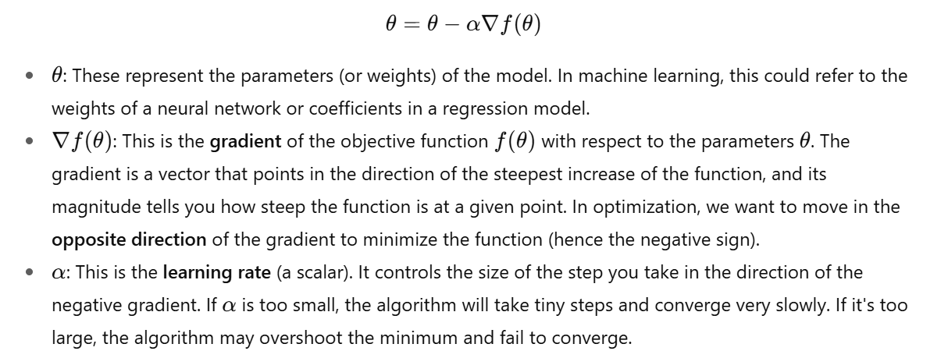
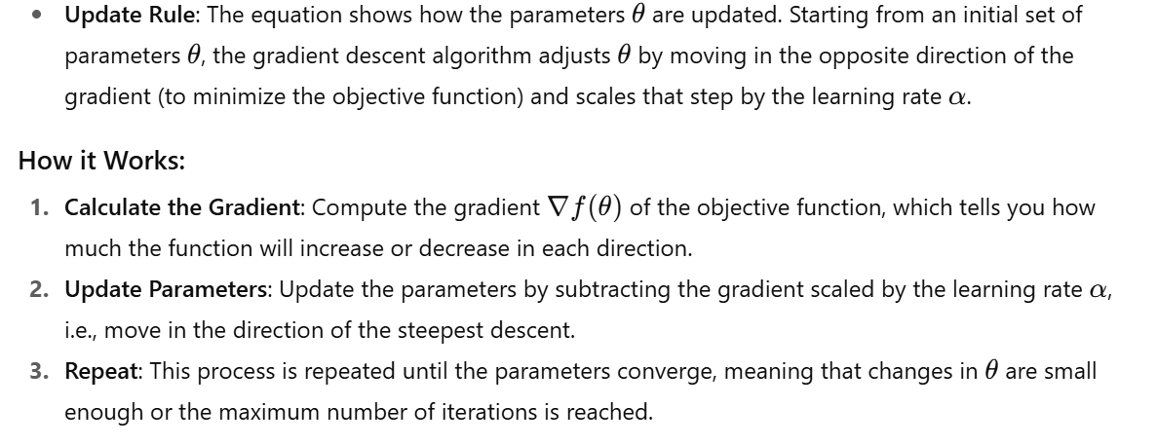
  - Repeat until convergence.

Use in Machine Learning:
- In training algorithms like linear regression, logistic regression, or neural networks, gradient descent is used to minimize the loss function, thereby improving the model's accuracy by updating the model's parameters (θtheta) iteratively.

Slide 6: Linear Programming (LP)
- Overview:
  - A method to optimize a linear objective function subject to linear equality and inequality constraints.
- Applications in AI:
  - Resource allocation, operations research, and decision-making models.
- Example:
  - Solving supply chain optimization problems.

Slide 7: Simulated Annealing
- Overview:
  - Inspired by the process of annealing in metallurgy, where materials are heated and then cooled to find the most stable state.
- Applications in AI:
  - Solving combinatorial optimization problems (e.g., TSP, job scheduling).
- Key Idea:
  - Explore the search space probabilistically, accepting worse solutions to escape local minima.

Slide 8: Particle Swarm Optimization (PSO)
- Overview:
  - A nature-inspired algorithm mimicking the social behavior of birds or fish.
- Key Elements:
  - Position: Represents a potential solution.
  - Velocity: Controls movement through the solution space.
  - pbest & gbest: Best known positions for each particle and the entire swarm.
- Applications:
  - Continuous function optimization, machine learning model tuning.

Slide 9: Genetic Algorithms
- Overview:
  - Mimics the process of natural selection, involving selection, crossover, and mutation to evolve solutions.
- Applications:
  - Feature selection, optimization problems in finance and robotics.
- Key Components:
  - Selection: Choose best solutions based on fitness.
  - Crossover: Combine solutions to create new solutions.
  - Mutation: Randomly alter solutions to introduce variety.

Slide 10: Ant Colony Optimization (ACO)
- Overview:
  - Inspired by the foraging behavior of ants, where they find the shortest path by leaving pheromones.
- Applications:
  - Combinatorial optimization problems like TSP, VRP.
- Key Idea:
  - Pheromone updating guides future search paths towards optimal solutions.

Slide 11: Comparing Optimization Techniques
- Table or Chart comparing various optimization techniques based on:
  - Speed
  - Convergence behavior
  - Complexity
  - Applicability to different types of problems (continuous, discrete, combinatorial).
Technique | Speed | Convergence | Complexity | Common Application
Gradient Descent | Fast | Local | Medium | Machine Learning (e.g., Neural Networks)
Linear Programming (LP) | Fast | Global | Low | Resource Optimization
Simulated Annealing | Medium | Global | High | Combinatorial Problems
PSO | Medium | Global | High | Hyperparameter Tuning
ACO | Medium | Global | High | Route Optimization

Slide 12: Hybrid Optimization Techniques
- What are Hybrid Techniques?
  - Combining multiple optimization methods to leverage their strengths (e.g., PSO + Simulated Annealing).
- Example:
  - Combining Genetic Algorithms with PSO to balance exploration and exploitation in high-dimensional spaces.

Slide 13: Applications in AI
- Machine Learning:
  - Hyperparameter tuning (e.g., optimizing neural networks).
  - Feature selection and dimensionality reduction.
- Robotics:
  - Path planning and control systems.
- Operations Research:
  - Resource allocation, logistics, and supply chain optimization.

Slide 14: Challenges in AI Optimization
- Premature Convergence:
  - The algorithm may get stuck in a local optimum and fail to explore better solutions.
- Scalability:
  - Optimization becomes difficult for high-dimensional spaces or large datasets.
- Parameter Sensitivity:
  - Optimization algorithms like PSO or Genetic Algorithms are sensitive to the choice of parameters (e.g., learning rates, population size).

Slide 15: Future Trends in AI Optimization
- Quantum Optimization:
  - Emerging field where quantum computing is used to solve optimization problems faster.
- Metaheuristics and Machine Learning:
  - Hybrid methods combining AI and optimization techniques to solve complex real-world problems (e.g., optimization of reinforcement learning agents).

Slide 16: Conclusion
- Key Takeaways:
  - AI optimization techniques play a crucial role in improving decision-making and problem-solving in AI applications.
  - Different techniques like Gradient Descent, PSO, and ACO have distinct advantages depending on the problem.
  - Future trends in optimization involve combining multiple techniques and leveraging emerging technologies like quantum computing.

Slide 17: Questions
- Any questions?
  - Open the floor for discussion.

Tips for Creating a Visually Engaging PPT:
- Use Diagrams and Flowcharts:
  - Illustrate algorithms like PSO, ACO, and Genetic Algorithms using simple visual representations.
- Keep Text Minimal:
  - Use bullet points to keep information concise.
  - Use large, readable fonts.
- Add Real-World Examples:
  - Include images or case studies of real-world AI optimization applications.
- Use Color Coding:
  - Use colors to highlight key sections (e.g., use green for advantages, red for challenges).
- Interactive Elements:
  - If your presentation platform supports it, add interactive elements or quizzes to engage the audience.

This outline gives you a strong framework for building a professional and informative presentation on AI optimization techniques. You can customize it with visuals, animations, and real-world examples to make it more engaging. Let me know if you'd like more details on any specific section or need help with slides!

